Magical mathematics

Card Trick
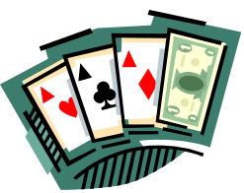

- Pick a card
- Add on the next number (J=11, Q=12, etc)
- Multiply by 5
- Add 1 for Hearts, 2 for Diamonds, 3 for Spades or 4 for Clubs

Repeat with a different card – can you predict the answer?
Why and how does this work?

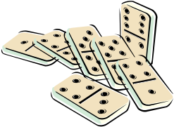

Domino Trick

- Pick a domino
- Double the highest number
- Multiply by 5
- Add on 4
- Add on the other number

Repeat with a different domino – can you predict the answer?
Why and how does this work?

Dice Trick
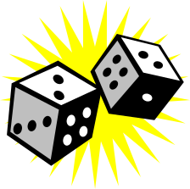

- Roll 2 dice
- Multiply the 2 top numbers together
- Multiply the 2 bottom numbers together
- Multiply the top number on the first die by the bottom number on the second die
- Multiply the bottom number on the first die by the top number on the second die
- Add the answers to your 4 multiplication sums together and subtract 7

What answer do you get?

Try the whole process again. What do you notice?

Packets of Crisps


- How many packets of crisps do you eat each day?
- Multiply by 2
- Add 5
- Multiply by 50
- Add 1754
- Subtract your year of birth
- Subtract 1 if you haven’t had your birthday this year

What does the answer tell you?

(This trick works if done in the year 2004. For every year above this, add 1 to 1754)

